**RIVERSIDE CITY COLLEGE**

**Assessment Guide**



Riverside Assessment Committee

Governance, Effectiveness, Mission, and Quality (GEMQ) Leadership Council.

Revised Spring 2021

**Table of Contents**

I. Introduction

II. Guiding Principles for Assessment

III. Assessment Cycle and Program Process

IV. Assessment and Guided Pathways

V. Assessment, Accreditation, and Strategic Planning

VI. Appendix:

1. Assessment Fundamentals
2. Levels of Assessment
3. Creating Effective Outcomes
4. Bloom’s Taxonomy
5. Resources
6. References
7. **Introduction**

Riverside City College believes that learning not only encompasses the knowledge of discrete facts and concepts but also the demonstration of the ability to integrate facts and concepts in critical, creative, and practical ways.

*Assessment Mission* *Statement*

The mission of assessment at Riverside City College is fourfold: (1) to equitably improve student success and learning, thus helping the College fulfill its educational mission; (2) to provide the evidence that allows the College to strengthen the content and delivery of its curriculum and services by identifying areas of strength and areas for improvement; (3) to allow space for conversations among all stakeholders about student learning, pedagogy, and equity; and (4) to encourage students’ agency in their own learning.

Assessment at RCC is overseen by the Riverside Assessment Committee (RAC). The RAC is a standing committee of the Academic Senate as established by Article III, Section 5 of the Academic Senate By-laws and is composed of faculty members from each department. The By-laws also indicate that the RAC should be composed of an additional 6 non-voting administrative and staff members representing a broad cross-section of the college community.

* The Riverside Assessment Committee recognizes the dual purpose of assessment as both summative and formative. While the committee strives to meet the external accountability demands of the accrediting commission and acknowledges the role of assessment in college planning processes and resource allocation decisions, its focus is on the intrinsic value of assessment as a means of improving student learning.
* The Riverside Assessment Committee supports both service area outcomes assessment and learning outcomes assessment by facilitating college-based activities and discussion, and by consulting with and providing guidance to departments, disciplines, and other units undergoing program review. The committee routinely and regularly seeks to foster engagement in learning outcomes assessment by encouraging dialogue related to pedagogy and curriculum, and supporting college-wide assessment efforts.

The responsibilities of the Riverside Assessment Committee include:

* Serving as consultants for assessment projects and as leaders to support a culture of assessment throughout the College
* Supporting College and department assessment representatives with information and resources, including technology, to maintain and carry out current assessment plans
* Regularly reviewing College assessment policies and procedures and recommending improvements as needed to the Academic Senate and College leadership
* Updating the College Assessment webpage with current developments, projects, and resources associated with assessment at Riverside City College and in the larger community of higher education
* Disseminating information gathered through assessment projects and facilitating assessment training College-wide

1. **Guiding Principles for Assessment**
2. The primary purpose of assessment is improving student learning.
   * By gathering meaningful evidence about student learning outcomes and processes, the College can make better decisions about pedagogy, curricular and co-curricular program and service design, and resource allocation to enhance a student's college experience.
3. Assessment of student learning depends on clear statements of expected outcomes.
   * These statements describe what the College expects students to know, be able to do, and value as a result of their college experience.
   * These statements should be informed by the mission statements of the College, the Departments and Disciplines, and individual programs, as well as faculty and staff intentions in program and course design.
4. Effective assessment attends not only to outcomes, but also to the experiences that lead to those outcomes.
   * Knowing about final outcomes is important, but in order to improve outcomes, the College needs to know about student experiences along the way – about teaching, the learning environment, curricula, co-curricular programs, and the kinds of student efforts that lead to particular outcomes.
   * By examining these processes, the College can align its work more effectively with the its mission and goals.
5. Assessment works best when it recognizes that learning is complex and multidimensional and occurs in a variety of settings.
   * Assessment should involve a diverse array of methods, including those that call for objective evidence of student performance, using this evidence over time so as to reveal change, growth, and increasing degrees of integration.
6. Assessment works best when it is designed to be meaningful, manageable, and sustainable.
   * It is embedded into the ongoing work of educating students.
   * Since assessment is designed to be meaningful, when necessary, assessment will drive larger discussions within the Departments and Disciplines to modify and/or change learning outcomes and other aspects of course or program curriculum.
7. Clear statements of expected student learning outcomes will guide the design and ongoing review of programs, processes, and curriculum.
   * Starting with learning outcomes, faculty can intentionally plan meaningful, diverse learning experiences that will lead to student achievement of the outcomes.
   * Starting with learning outcomes, faculty can embed manageable assessment methods into program design and ongoing review processes.
8. The College is committed to an ongoing program of assessment of student learning.
   * The College will provide the necessary resources for assessment activities, including professional development for faculty and staff.
   * The College supports the integration of assessment with curriculum design, program review, institutional research and planning, and resource allocation.
9. **Assessment Cycle and the Program Review Process**

In an effort to better align assessment and program review with planning, Riverside City College has revised its Program Review process. The process includes annual assessment cycles and reports for every discipline and department, and a comprehensive program review in year five of the cycle.

During a Program Review Cycle, a discipline and department will:

1. Create an assessment plan including which terms each SLO, PLO, and / or SAO will be assessed.
2. Review and update the discipline’s curriculum map.
   * Completing a curriculum map allows the program to identify gaps in the curriculum. Mapping course-level SLOs to program-level PLOs and noting discrepancies, inconsistencies, and gaps in the curriculum, ensures that the courses in the program (and any relevant co-curricular activity) align with the PLOs. This is usually best accomplished by means of a matrix. When completed, this mapping and aligning project may reveal gaps in the curriculum or specific PLOs that might be unachievable without making some courses, or groups of courses, required.
3. Review each Course Outline of Record (COR) in the discipline at least once during a program review cycle based on the discipline’s/department’s assessment discussions.
4. Assess *EACH* SLO, PLO, and / or SAO *AT LEAST ONCE* during the program review cycle.
5. Complete yearly updates, reporting on the progress of initiatives, activities, and goals using quantitative and qualitative results as evidence.
6. **Assessment and Guided Pathways**

The College uses Guided Pathways as a framework to increase student success and as a lens to integrate the many on-going efforts designed to help students choose a career, successfully enroll in and complete coursework, and progress toward a certificate, degree, and/or transfer opportunity. Guided Pathways has four pillars, and assessment is a component of each:

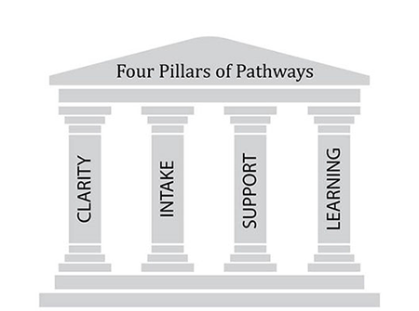

Clarity:

Clarity means that the College creates clear curricular pathways to employment and further education. This has been done through creating program maps that simplify students’ choices and establishing transfer pathways with clear learning outcomes. Assessment of both SLOs and the College’s work with transfer partners and employers are two ways that assessment plays a role in the first pillar.

Intake:

Intake includes helping students choose and enter their pathway. This is being done with integrated supports for transfer-level math and English courses, training for academic support staff, RCC’s Promise Program, and outreach to feeder high schools to name just a few. Service-area outcome (SAO) assessment plays a role in each of these activities to help leads see which supports are working, which aren’t, and which need additional resources.

Support:

Support means helping students stay on their path. RCC is doing this in service areas with academic support teams, faculty advising, and engagement centers as well as in academic areas through curriculum. Both SAO and SLO assessment support this third pillar.

Learning:

This pillar specifies that RCC ensures learning. This is done by establishing SLOs that support PLOs (program-level outcomes), by ensuring best practices and effective teaching practices are used in the classroom, and by using data to study results. Assessment of SLOs, PLOs, and faculty development support this fourth pillar.

1. Assessment, Accreditation, and Strategic Planning

Strategic planning is an organization's process of defining its direction and making decisions on allocating its financial and human resources to pursue this direction. RCC’s strategic planning process consists of:

* Reviewing and updating Mission, Vision, and Values
* Analyzing data and identifying issues
* Sharing vision and goals with stakeholders and College Councils
* Developing strategies, planned activities, performance indicators and benchmarks and identifying resources
* Assigning responsibilities
* Implementing Strategic Plan initiatives
* Conducting assessments and completing the Annual Report Card

RCC’s strategic planning web site address is <http://www.rcc.edu/riverside/riversidestp/index.cfm>

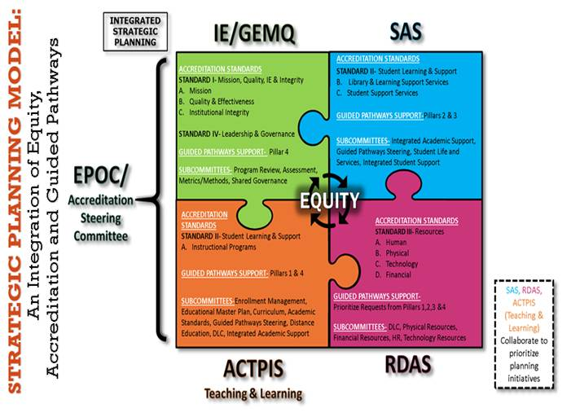The graphic below shows how assessment is tied to accreditation and strategic planning:

**Appendices**

**Appendix A: Assessment Fundamentals**

*What is Assessment?*

Assessment is the use of evidence-based, systematic, and intentional processes to enhance and improve student learning (Moore Gardner, Kline & Bresciani, 2014).

While traditional outcome metrics such as course success, student persistence, degrees and certificates awarded, and transfer rates are used to measure progress, the results from ongoing assessment are critical tools that inform conversations about improvement and student success and provide better understanding of what students know and are able to do. Gathering meaningful evidence about student learning outcomes and processes helps the College make better decisions about pedagogy, the design of curricular and co-curricular programs and services, and how to better allocate resources to enhance a student’s college experiences.

*Assessment is…*

* Faculty-driven for all academic areas – courses, programs, certificates, and degrees
* Used to inform conversations about ways to improve student learning and development
* Used to evaluate the outcomes for non-academic areas including Student Services and Administrative Units
* Integral to the Program Review Process
* Dynamic, cyclical, and sustainable

One of the common concerns about assessment is that it is an external, top-down imposition upon faculty, and assessment results may be used to evaluate faculty. However, Riverside City College faculty members are primarily responsible for assessment, and thus have direct responsibility for establishing learning outcomes, identifying processes for assessing them, verifying whether they have been reached, and pursuing future directions. This is further codified in the Faculty Memorandum of Agreement: Assessment “shall not be used as a criterion of evaluation.”

*What are Learning Outcomes?*

The Academic Senate for California Community Colleges (ASCCC) defines student learning outcomes as:

Student learning outcomes (SLOs) are the specific observable or measurable results that are expected subsequent to a learning experience. These outcomes may involve knowledge (cognitive), skills (behavioral), or attitudes (affective) that provide evidence that learning has occurred as a result of a specific course, program activity, or process. An SLO refers to an overarching outcome for a course, program, degree or certificate, or student services area (such as the library). SLOs describe a student’s ability to synthesize many discreet skills using the higher level thinking skills and to produce something that asks them to apply what they’ve learned. (ASCCC *SLO Terminology Glossary*, 2010, pg. 13).

*Assessment works best when:*

It recognizes that learning is complex and multidimensional, and occurs in a variety of settings.

* Assessment should involve a diverse array of methods, including those that call for objective evidence of student performance, using them over time so as to reveal change, growth, and increasing degrees of integration.
* Using a variety of assessment methods is culturally responsive, helps to grant students agency, and leads to students becoming more independent learners.
* Assessment of student learning can be done either directly or indirectly. Direct assessment provides “tangible, visible, self-explanatory and compelling evidence of exactly what students have and have not learned” (Suskie, 2009, p. 20). Direct assessment includes student papers, student exams, and group presentations. Indirect assessment is “Less clear and less convincing than direct evidence” (Suskie, 2009, p. 20). Indirect assessment demonstrates students have probably learned something. Indirect assessment may include group discussions after a lab, student surveys, retention and graduation rates, or course grades. See Appendix C for additional examples of direct and indirect assessments.

Assessment is designed to be meaningful, manageable, and sustainable.

* The evidence collected and used to assess outcomes should not be so difficult or complex that its collection requires substantial work as a stand-alone activity.
* Evidence should be embedded into the ongoing work of educating students or the ongoing processes of a non-instructional unit.

Assessment acknowledges that measuring students’ inputs and environment as well as outcomes creates a more fully contextualized picture of a student’s experiences.

* Knowing about final outcomes is important, but in order to improve outcomes, we also need to understand how student experiences—teaching, the learning environment, curricula, co-curricular programs—affect these outcomes (Bresciani, Moore Gardner, & Hickmott, 2009).
* By examining these processes, we can align our work more effectively with the College’s mission and goals.

Assessment is designed with at least one of three purposes in mind: to improve, to inform, and/or to prove.

* “The results from an assessment process should provide information that can be used to determine whether or not [sic] intended outcomes are being achieved and how the programs can be improved. An assessment process should also be designed to inform departmental faculty and other decision-makers about relevant issues that can impact the program and student learning.” (University of Massachusetts, Amherst, “Program-Based Review And Assessment Tools And Techniques For Program Improvement,” [2001], 7; adapted from the University of Wisconsin-Madison, “Using Assessment for Academic Program Improvement, [April 2000]).

**Appendix B: Levels of Assessment**

Instructional assessment is conducted simultaneously at many different levels throughout the college. At the foundational level, **classroom assessment** is done by individual faculty within the context of individual classes. Formal and informal evidence of learning is collected and assessed. The results of assessment are used to inform conversations and activities focused on improving student learning.

Non-instructional assessment is conducted at the unit level using Service Area Outcomes (SAO’s). As with instructional assessment, evidence of progress for each SAO should be collected and assessed. The results of these assessment activities should inform improvement conversations at the unit, department, discipline, and College levels and provide evidence-based metrics which can be used to evaluate the effectiveness of processes and services.

**Institution-level Assessment**

Institution-level assessment is assessment of Institution Learning Outcomes. These outcomes are set by each College.

**Program-level Assessment**

Program Learning Outcomes (PLOs) are defined by faculty and reflect the skills and knowledge a student will gain through a program’s sequenced curriculum. Often, PLOs are informed by a licensure or certification exam. The program assessment process is designed to align course-level SLOs and curriculum requirements with PLOs. PLO assessment results inform conversations and decision at the discipline, department, and College levels. PLO’s are the same throughout the District.

**Course-level Assessment**

Course-level assessment measures student learning for a particular course. Each SLO must be assessed at least once during each Program Review cycle. SLOs are approved by the College’s Curriculum Committee and appear on the Course Outline of Record (COR) within META. It is important to emphasize that course-level assessment is a measure of what students have learned in the course regardless of who was teaching it. Assessment results are used by faculty in the discipline to inform activities, to review and improve CORs, and to implement changes to instruction to improve student learning. Course-level SLO’s are the same throughout the District.

**General Education Assessment**

General Education assessment measures the skills and knowledge the College expects students to demonstrate upon completion of an A.A. or A.S. degree. The Academic Senate empowers the Riverside Assessment Committee to direct the assessment process of these GESLOs, which are set by each College.

* In practice, most degree-bound students at RCCD complete a broader Gen Ed program as required by UC (IGETC) or by CSU (IGETC plus US History, Constitution, and American Ideals).
* In defining and assessing RCCD Gen Ed outcomes at RCC, the College is guided by the 2016 ACCJC accreditation standards. “General education courses are checked to ensure students achieve comprehensive learning outcomes in the degree program” including the following:
  + An understanding of the basic content and methodology of the major areas of knowledge: areas include the humanities and fine arts, the natural sciences, and the social sciences.
  + A capability to be a productive individual and life-long learner: skills include oral and written communication, information competency, computer literacy, scientific and quantitative reasoning, critical analysis/logical thinking, and the ability to acquire knowledge through a variety of means.
  + A recognition of what it means to be an ethical human being and effective citizen: qualities include an appreciation of ethical principles; civility and interpersonal skills; respect for cultural diversity; historical and aesthetic sensitivity, and the willingness to assume civic, political, and social responsibilities locally, nationally, and globally.
* GE SLO assessment results and recommendations are shared with key stakeholders across campus including department chairs and Academic Senate.
* RCC’s General Education Program Student Learning Outcomes were revised in 2012. They can be found at: <http://academic.rcc.edu/assessment/files/GenEdSLORevisedFinal.pdf>

**Non-Instructional Assessment**

Administrative and Student Services departments develop and assess Service Area Outcomes (SAOs) to ensure units are examining programs and services, to provide data for review and discussion, to document internal improvement efforts, to allow staff to prioritize projects and improvements, and to provide rationale for resource requests. An SAO is a specific **statement** that describes the **benefit** that a unit hopes to achieve or the **impact** that is a result of work that a unit performs. The purposes of non-instructional assessment include:

* Evaluation of how well a learning resource, student service area or administrative unit functions in relation to its plan, the mission of the College and unit, the College's institutional goals and priorities, and the needs of the community.
* A framework to strengthen and integrate planning and decision making.
* Encouragement of program or unit development and improvement.
* Improvement of the use of College resources.
* Compliance with accreditation and matriculation requirements.

Student Services Units may also develop SLOs to describe what a student should know or be able to do after participating in or receiving a particular service. For SLOs, while the results for the outcome indicate whether the unit should strive for improvement, the burden is more on the student as his/her knowledge and/or abilities are assessed based on the service received. An example of an SLO for Counseling is “The student will be able to state an informed academic goal.”

The focus for Administrative and Student Services Unit assessments is on clients’ needs and satisfaction and on the effects for clients. “Clients” may refer to students, faculty, staff, and/or the public. Using data already collected, such as the types and frequencies of services offered, is recommended. Methods of assessment for Administrative and Student Services Units may include but are not limited to the following:

* CCSSE and RCC Student Satisfaction Surveys
* Number and types of complaints
* Growth in a specific function
* Comparisons to professional organizations’ best practices
* Focus groups
* Time to complete a task
* Student data on enrollment, retention, success, goal attainment, etc.
* Faculty data on professional development, use of emerging technologies, grant proposal development and subsequent funding, etc.

This diagram shows how each type of outcome support student success.

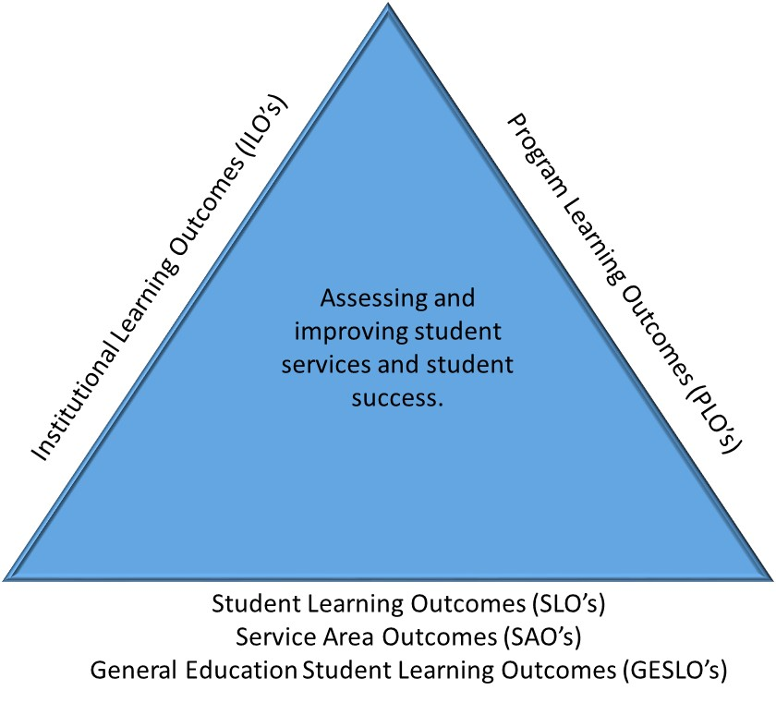

**Appendix C: Creating Effective Outcomes**

Creating an affective assessment cycle begins with a sense of course, program, and / or institutional goals and mission. Much of what faculty hope a course or program will accomplish centers on fostering student learning and increasing their competencies, knowledge, and skills. Creating effective student learning outcomes and designing successful assessment strategies starts by identifying what they want students to learn, understand, and be able to do upon successful completion of their studies.

Using assessment results, often called “closing the loop,” is a key step in the assessment cycle. Closing the loops means that courses, programs, and the institution use assessment results to improve student services and increase student success. The steps in Riverside City College’s assessment cycle are:

*Plan: Clearly Identify and Define Student Learning Outcomes (SLOs) and other outcomes*

* Outcomes are concise, measurable statements about what a student should know, think, or be able to do upon completion of a course.
* Outcomes are written using action verbs which follow the higher-order skills on Bloom’s Taxonomy (See Appendix D).
* “[F]aculty engaged in SLO activities must understand the difference between the content of the class and the steps that establish the framework for student learning on one hand and the overarching, observable knowledge, skills, or behavior to which those steps should lead on the other.” (ASCCC *Guiding Principles for SLO Assessment,* 2010, pg. 5).

*Assess: Provide Learning Opportunities and Gather Evidence*

* Assessment works best when it is ongoing, not episodic. Assessment is a process whose power is cumulative. Though isolated, “one-shot” assessment can be better than none, improvement is best fostered when assessment entails a linked series of activities undertaken over time. This may mean tracking the process of individual students, or of cohorts of students; it may mean collecting the same examples of student performance or using the same instrument semester after semester. The point is to monitor progress toward intended goals in a spirit of continuous improvement. Along the way, the assessment process itself should be evaluated and refined in light of emerging insights.
* Success can be demonstrated by the student in several ways:
  + *Cognitive Outcome:* What does a course / program want a successful student to know?
  + *Affective Outcome:* What does a course / program want a successful student to think or care about?
  + *Behavior Outcome*: What does a course /program want a successful student to be able to do?
* Classroom activities are only one source of learning activities on campus. Other activities may include learning through co-curricular programs or student services initiatives.
* Assessment strategies and methods are essential to being able to arrive at answers to the questions that faculty have about how courses or programs are doing with respect to student learning.
* Assessment methods should be selected based on the resources, time, people, materials, etc. available.
* Most importantly, assessment efforts should provide useful feedback.
* When considering assessment methods, there may not be a single measure for all of the outcomes. It is likely that different measures will be needed for different outcomes.
* Measures can be direct or indirect, although indirect measurement alone does not usually provide sufficient evidence of student learning.
* Typically, grades are not used as evidence of student learning as they do not give the full details of what students demonstrated about their learning.
  + Grades can be used to report on success, but often don’t provide feedback to the student, instructor, course, or program about what needs to be done to achieve a higher success level.
* Examples of direct methods of assessment include:
  + External Licensure Exams
  + Culminating project / Capstone
  + Exam
  + Homework assignment
  + Portfolio
  + Pre-test / post-test
  + Video
  + Writing assignment
* Examples of indirect methods of assessment include:
  + Anecdotal data
  + Focus group
  + Interview
  + Student-reported survey

Adapted from The Educational Assessment Committee (2013.) *Program-Based Assessment Tools and Guide*. University of Redlands.

*Analyze: Report and Discuss the Assessment Results*

* Riverside City College uses Nuventive Improve as the software for collecting and recording assessment results. Nuventive Improve is also used for completing discipline and department program reviews as well as annual updates.
* The results should be recorded in Nuventive Improve and used to inform conversations at the Discipline, Department, and Institutional levels regarding improving student services and success.
* Questions which assessment results may help answer include:
  + What does the data say about students’ mastery of a learning outcome?
  + Where are students doing exceptionally well?
  + Where are students consistently not doing well?
  + Where do faculty want to see higher levels of performance and how might we use the data to facilitate this?
* Regardless of the audience, assessment results should be reported. The report should include why the assessment was done, what the results of the assessment were, how the findings will be used, and what changes might be made to the assessment plan and processes in the future.
* While all faculty should play a role in assessing student learning outcomes and discussing assessment results, reporting of the results in Nuventive Improve may or may not be a responsibility of associate faculty. This will differ department by department depending on individual departments’ needs.

*Improve: Determine actions to improve*

* Use assessment results to improve student learning through informed collegial dialogue at the discipline, department, division, and institutional level.
* This is part of the continuous cycle of collecting assessment results, evaluating the results, using the evaluations to identify actions that will improve student learning, implementing those actions, and then cycling back to collecting assessment results, etc.
* Continuous improvement is reflected when an on-going, cyclical process is used to identify evidence and implement incremental changes to improve student learning.
* On a five-year cycle, assessment results will be included as part of the program review. These results will help provide evidence for course changes or program improvement.
  + If additional resources are needed to implement an improvement, the evidence collected during the assessment cycle will help articulate the need for these resources.
* On-going, evidence-based discussion will also create stronger alignment of courses and programs with the College’s strategic plan and mission.

**Appendix D: Bloom’s Taxonomy**

*Bloom’s Taxonomy* provides a method of classifying cognitive skills, which can be useful when developing learning outcomes. Bloom’s taxonomy presents six categories, and below each is a list of action verbs:

|  |  |  |  |  |  |
| --- | --- | --- | --- | --- | --- |
| **Knowledge** | **Comprehension** | **Application** | **Analysis** | **Synthesis** | **Evaluation** |
| Count  Define  Describe  Draw  Identify  Labels  List  Match  Name  Outlines  Point  Quote  Read  Recall  Recite  Recognize  Record  Repeat Reproduces Selects  State  Write | Associate  Compute  Convert  Defend  Discuss  Distinguish  Estimate  Explain  Extend  Extrapolate  Generalize  Give examples  Infer  Paraphrase  Predict  Rewrite  Summarize | Add  Apply  Calculate  Change  Classify  Complete Compute Demonstrate Discover  Divide  Examine  Graph  Interpolate Manipulate Modify  Operate  Prepare  Produce  Show  Solve | Analyze  Arrange Breakdown Combine  Design  Detect  Develop  Diagram Differentiate Discriminate Illustrate  Infer  Outline  Point out  Relate  Select  Separate Subdivide  Utilize | Categorize  Combine  Compile  Compose  Create  Drive  Design  Devise  Explain  Generate  Group  Integrate  Modify  Order  Organize  Plan  Prescribe Propose Rearrange Reconstruct | Appraise  Assess  Compare Conclude Contrast  Criticize  Critique Determine  Grade  Interpret  Judge  Justify  Measure  Rank  Rate  Support  Test |

Anderson, L. W., & Krathwohl, D. R. (Eds.). (2001). *A taxonomy for learning, teaching and assessing: A revision of Bloom's Taxonomy of educational objectives: Complete ed*ition. New York: Longman.

Bloom, Benjamin S. & David R. Krathwohl. (1956). *Taxonomy of educational objectives: The classification of educational goals, by a committee of college and university examiners. Handbook 1: Cognitive domain*. New York: Longmans.

**Appendix E: Resources**

Academic Senate for California Community Colleges Guiding Principles for SLO Assessment**:** [**http://www.asccc.org/papers/guiding-principles-slo-assessment**](http://www.asccc.org/papers/guiding-principles-slo-assessment)

Cult of Pedagogy podcast: Culturally Responsive Teaching: 4 Misconceptions

<https://www.cultofpedagogy.com/culturally-responsive-misconceptions/>

Glossary: <https://www.rcc.edu/about/president/strategic-planning/Documents/Strategic-Planning-Document/SP_Glossary_Oct5_10.pdf>

National Institute for Learning Outcomes Assessment: <http://www.learningoutcomesassessment.org/>

Riverside City College Learning Outcomes Assessment homepage: <http://academic.rcc.edu/assessment/>

Riverside City College Nuventive homepage: <http://academic.rcc.edu/assessment/tracdat.htm>

**Appendix F: References**

Academic Senate for California Community Colleges [ASCCC] (2010). *Guiding Principles for*

*SLO Assessment.* Sacramento, CA. 2010.

Academic Senate for California Community Colleges [ASCCC] (2010). *SLO Terminology*

*Glossary: A Resource for Local Senates.* Sacramento, CA. 2010.

Anderson, L. W., & Krathwohl, D. R. (Eds.). (2001). *A taxonomy for learning, teaching and*

*assessing: A revision of Bloom's Taxonomy of educational objectives: Complete edition*.

New York, NY: Longman.

Bloom, B. S. & Krathwohl, D.R. (1956). *Taxonomy of educational objectives: The classification*

*of educational goals, by a committee of college and university examiners. Handbook 1:*

*Cognitive domain.* New York, NY: Longmans.

Bresciani, M., Moore Gardner, M., & Hickmott, J. (2009). *Demonstrating Student Success.*

Sterling, VA: Stylus Publishing, LLC.

Moore Gardner, M., Kline, K., & Bresciani, M. (Ed.). (2014). *Assessing student learning in the*

*community and two-year college.* Sterling, VA: Stylus Publishing, LLC.

Suskie, L. (2009). *Assessing student learning: A common sense guide* (2nd ed.). San Francisco, CA: Jossey-Bass.

The Educational Assessment Committee (2013). *Program-Based Assessment Tools and Guide.* University of Redlands.

University of Massachusetts, Amherst, “Program-Based Review And Assessment Tools And

Techniques For Program Improvement,” [2001], 7; adapted from the University of

Wisconsin-Madison, “Using Assessment for Academic Program Improvement, [April

2000].